Money Module Test

Name : Neron Nelson Parmar

Student ID : 171690217

Email ID : nparmar22@myseneca.ca

Course : SYD366

Prof : Hesam Akbari

Test : Money Module Test

**Question 1:**

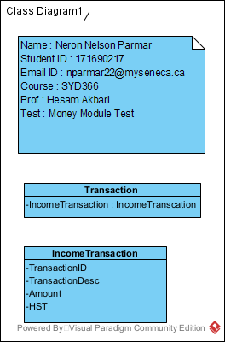

**Question 2 and 3:**

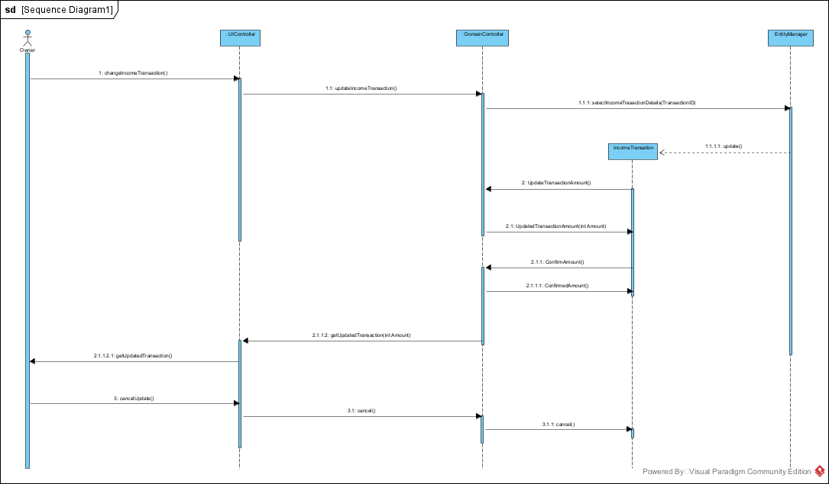

**Question 4:**

#ifndef _SDDS_INCOMETRANSACTION_H

#ifdef _SDDS_INCOMETRANSACTION_H

Namespace sdds{

Class IncomeTransaction{

string TransactionID;

string TransactionDesc;

int Amount;

double HST;

changeIncomeTransaction();

updateIncomeTransaction();

selectIncomeTransactionDetails(string TransactionID);

update();

UpdateTransactionAmount();

UpdatedTransactionAmount(int Amount);

ConfirmAmount();  
ConfirmedAmount();

getUpdatedTransaction(int Amount);

getUpdatedTransaction();

cancelUpdate();

cancel();

cancel();

};

}

**Question 5:**

For taking care of the records of we can add a new attribute to the class and this can help to keep all the transaction details. However, it won’t change any kind of detailing in the model.

**Question 6:**

Even if the customers pay with the cheque there will be no such difference found in the amount. And if Ava accepts it from paying by the cheque it will be be the inclusive of all the taxes and would include the HST around the 10% and will also have the benefit of claiming the taxes as well. However, talking about the model it wouldn’t change even if the amount if payed using the cheques. Apart from this, paying cheque will help in keep the transaction details.